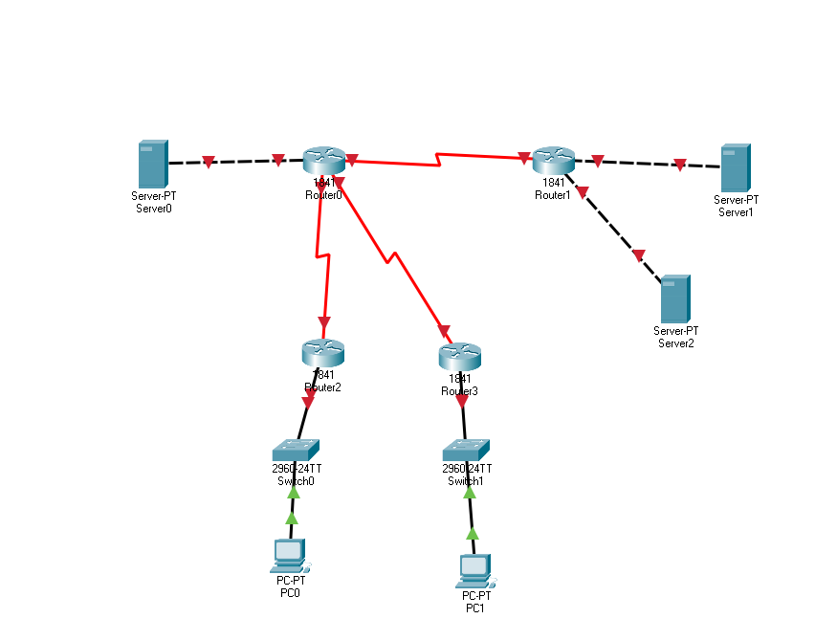

Comenzi:

Enable

Config t

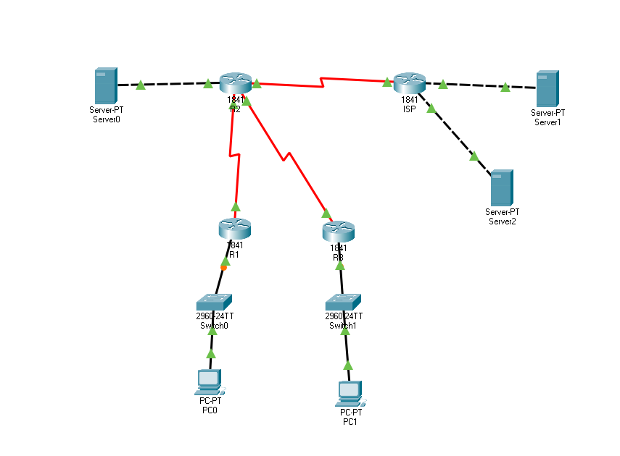

ISP:

* La fast Ethernet ip urile sunt pe masca de 32 si primul IP terminandu-se in 158, vor fi din 32 in 32 de valori pana la 224, de aici rezulta valoarea de 190

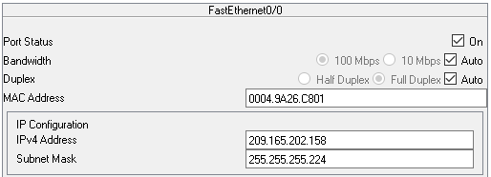

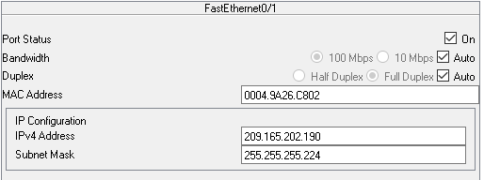

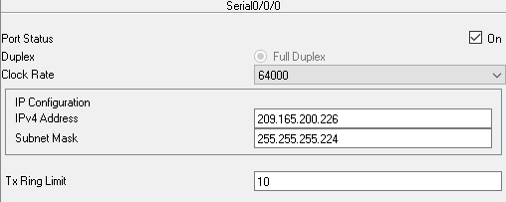

R2

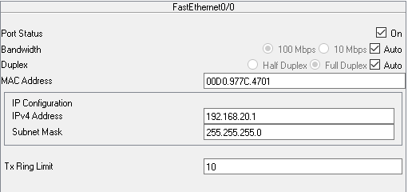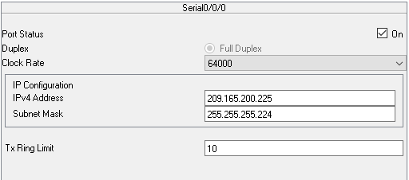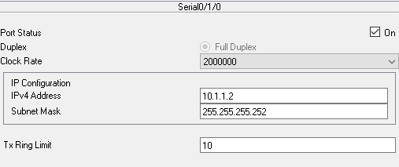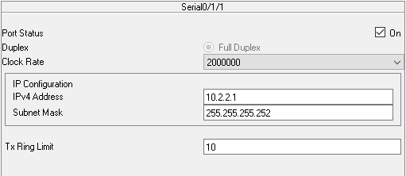

R1

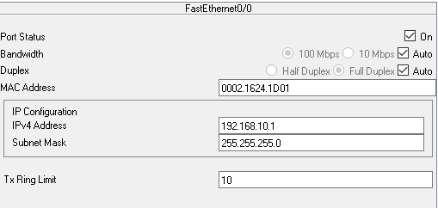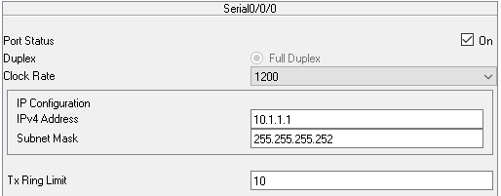

R3

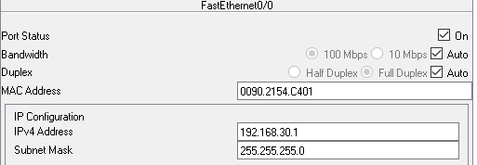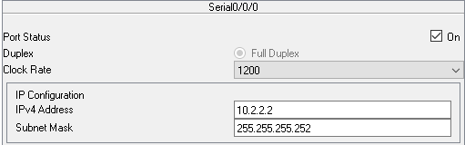

PC-uri

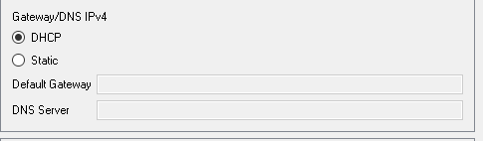

Server dns

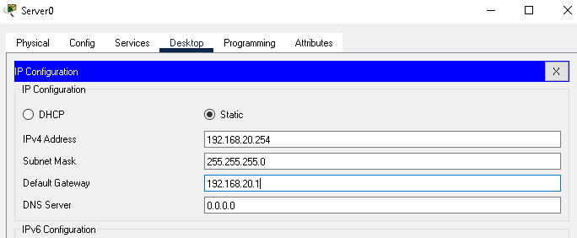

Server1

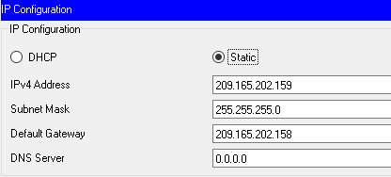

Server 2

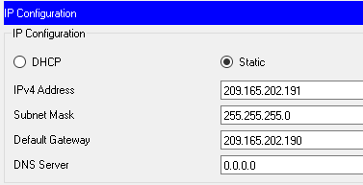

R1 si R3( pt R3 in loc de 192.168.10.* este 192.168.30.*)

Router>enable

Router#config t

Enter configuration commands, one per line. End with CNTL/Z.

Router(config)#ip dhcp ex

Router(config)#ip dhcp excluded-address 192.168.10.2

Router(config)#ip dhcp excluded-address 192.168.10.3

Router(config)#ip dhcp excluded-address 192.168.10.3

Router(config)#ip dhcp excluded-address 192.168.10.4

Router(config)#ip dhcp excluded-address 192.168.10.5

Router(config)#ip dhcp excluded-address 192.168.10.6

Router(config)#ip dhcp excluded-address 192.168.10.7

Router(config)#ip dhcp excluded-address 192.168.10.8

Router(config)#ip dhcp excluded-address 192.168.10.9

Router(config)#ip dhcp excluded-address 192.168.10.10

Router(config)#ip dhcp pool R1LAN

Router(dhcp-config)#network 192.168.10.0 255.255.255.0

Router(dhcp-config)#def

Router(dhcp-config)#default-router 192.168.10.1

Router(dhcp-config)#dns

Router(dhcp-config)#dns-server 192.168.20.254

PC1 – dhcp

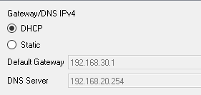

**PC0 – dhcp**

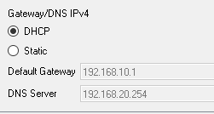

**R1**

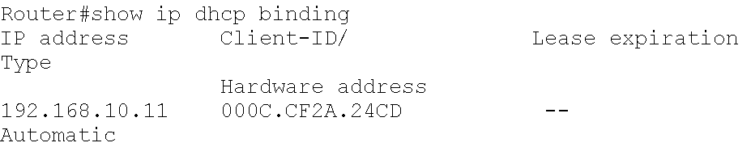

**R3**

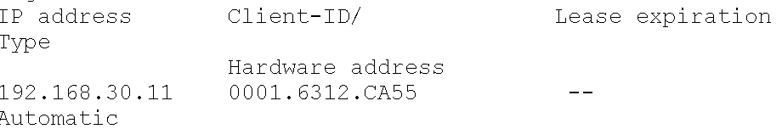

**Server DNS**

